Alarm: ID 16: Master Link Down
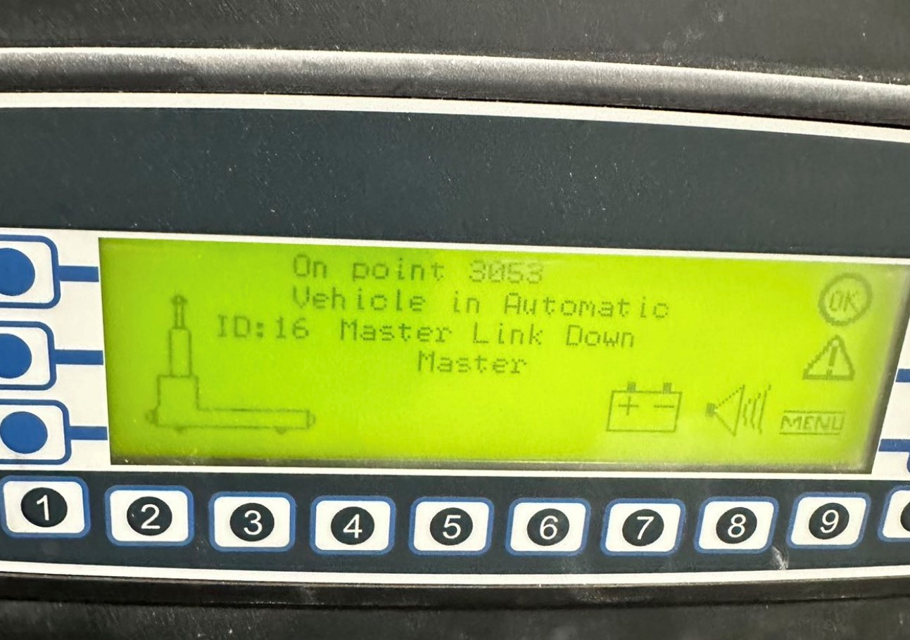
How To Fix:
This alarm occurs when the AGV loses connection with its local server, typically right after the AGV is powered on.
To resolve:
- Wait for the AGV to reconnect automatically.
- If the alarm persists, reboot the AGV.
- If the issue continues, contact a qualified AGV Technician for further assistance.

